TASK: LED SEQUENCE V1.0

AUTHOR: MOHAMMED ABDEL-WAHAB

**Layered Architecture:**

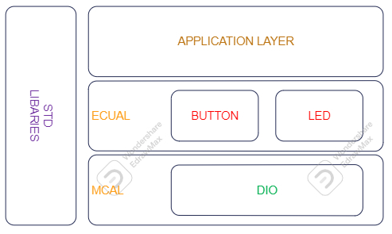

**State machine diagram for the main flow of the Application:**

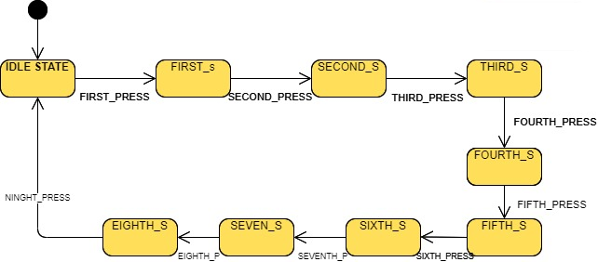

* IDLE STATE: ALL LEDS ARE OFF
* FIRST STATE: LED 0 IS ONLY ON
* SECOND STATE: LED 0 & LED 1 ARE ON
* THIRD STATE : LED 0 & LED 1 & LED 2 ARE ON
* FOURTH STATE: ALL LEDS ARE ON
* FIFTH STATE: LED 0 IS ONLY OFF
* SIXTH STATE: LED 0 & LED 1 ARE OFF
* SEVENTH STATE: LED 0 & LED 1 & LED 2 ARE OFF
* EIGHTH STATE: ALL LEDS ARE OFF

**A project APIs:**

DIO DRIVER:

/**

* @brief Initialize the direction of specific pin @ref direction_t

* @param _pin_config A Reference of the pin configuration @pin_config_t

* @return status of the function

* E_OK :the function done successfully

* E_NOT_OK :the function has issues performing the function

*/

Std_ReturnType DIO_pin_direction_intialize(const pin_config_t *pin_config_ptr,direction_t a_direction);

/**

* @brief Write the logic of specific pin @ref logic_t

* @param _pin_config A Reference of the pin configuration @pin_config_t

* @param logic

* @return status of the function

* E_OK :the function done successfully

* E_NOT_OK :the function has issues performing the function

*/

Std_ReturnType DIO_pin_write_logic(const pin_config_t *pin_config_ptr,const logic_t a_logic);

/**

* @brief Read the logic of specific pin @ref logic_t

* @param _pin_config A Reference of the pin configuration @pin_config_t

* @param logic

* @return status of the function

* E_OK :the function done successfully

* E_NOT_OK :the function has issues performing the function

*/

Std_ReturnType DIO_pin_read_logic(const pin_config_t *pin_config_ptr, logic_t *logic_ptr);

/**

* @brief Toggle the logic of specific pin @ref logic_t

* @param _pin_config A Reference of the pin configuration @pin_config_t

* @return status of the function

* E_OK :the function done successfully

* E_NOT_OK :the function has issues performing the function

*/

Std_ReturnType DIO_pin_toggle_logic(const pin_config_t *pin_config_ptr);

/**

* @brief Initialize the direction of specific pin and Initialize its logic

* @param _pin_config A Reference of the pin configuration @pin_config_t

* @return status of the function

* E_OK :the function done successfully

* E_NOT_OK :the function has issues performing the function

*/

/*

Std_ReturnType DIO_pin_intialize(const pin_config_t *pin_config_ptr);

*/

/**

*

* @param port_index

* @param direction

* @return status of the function

* E_OK :the function done successfully

* E_NOT_OK :the function has issues performing the function

*/

Std_ReturnType DIO_port_direction_intialize(const port_index_t a_port_index, uint8_t a_direction);

/**

* @param port_index

* @param logic

* @return status of the function

* E_OK :the function done successfully

* E_NOT_OK :the function has issues performing the function

*/

Std_ReturnType DIO_port_write_logic(const port_index_t a_port_index , uint8_t a_logic);

/**

* @param port_index

* @param logic

* @return status of the function

* E_OK :the function done successfully

* E_NOT_OK :the function has issues performing the function

*/

Std_ReturnType DIO_port_read_logic(const port_index_t a_port_index , uint8_t *const a_logic_ptr);

/**

* @param port_index

* @return status of the function

* E_OK :the function done successfully

* E_NOT_OK :the function has issues performing the function

*/

Std_ReturnType DIO_port_toggle_logic(const port_index_t a_port_index);

LED DRIVER:

/**

* @breif Initialize The led by configuring the pin as output and write low

* @param Led The reference of the led module configuration

* @return status of the function

* E_OK :the function done successfully

* E_NOT_OK :the function has issues performing the function

*/

Std_ReturnType LED_initialize(const led_t *led_ptr);

/**

* @breif Turn the led on

* @param led The reference of the led module configuration

* @return status of the function

* E_OK :the function done successfully

* E_NOT_OK :the function has issues performing the function

*/

Std_ReturnType LED_turn_on(const led_t *led_ptr);

/**

* @breif Turn the led off

* @param led The reference of the led module configuration

* @return status of the function

* E_OK :the function done successfully

* E_NOT_OK :the function has issues performing the function

*/

Std_ReturnType LED_turn_off (const led_t *led_ptr);

/**

* @breif Toggle the led

* @param led The reference of the led module configuration

* @return status of the function

* E_OK :the function done successfully

* E_NOT_OK :the function has issues performing the function

*/

Std_ReturnType LED_turn_toggle (const led_t *led_ptr);

BUTTON DRIVER:

/**

* @breif Initialize The assigned pin to be input

* @param btn he reference of the button module configuration

* @return status of the function

* E_OK :the function done successfully

* E_NOT_OK :the function has issues performing the function

*/

Std_ReturnType BTN_init(const button_t *btn_ptr);

/**

* @breif Read the push button if is it pressed or released

* @param btn The reference of the button module configuration

* @param btn_state The reference of the variable that store the button status @ref button_status_t

* @return status of the function

* E_OK :the function done successfully

* E_NOT_OK :the function has issues performing the function

*/

Std_ReturnType BTN_read_state(const button_t *btn_ptr, button_status_t *btn_states_ptr);